Hi everyone,

What is closer connected with what you think prayer is all about?
- Special set-apart moments or your everyday life?
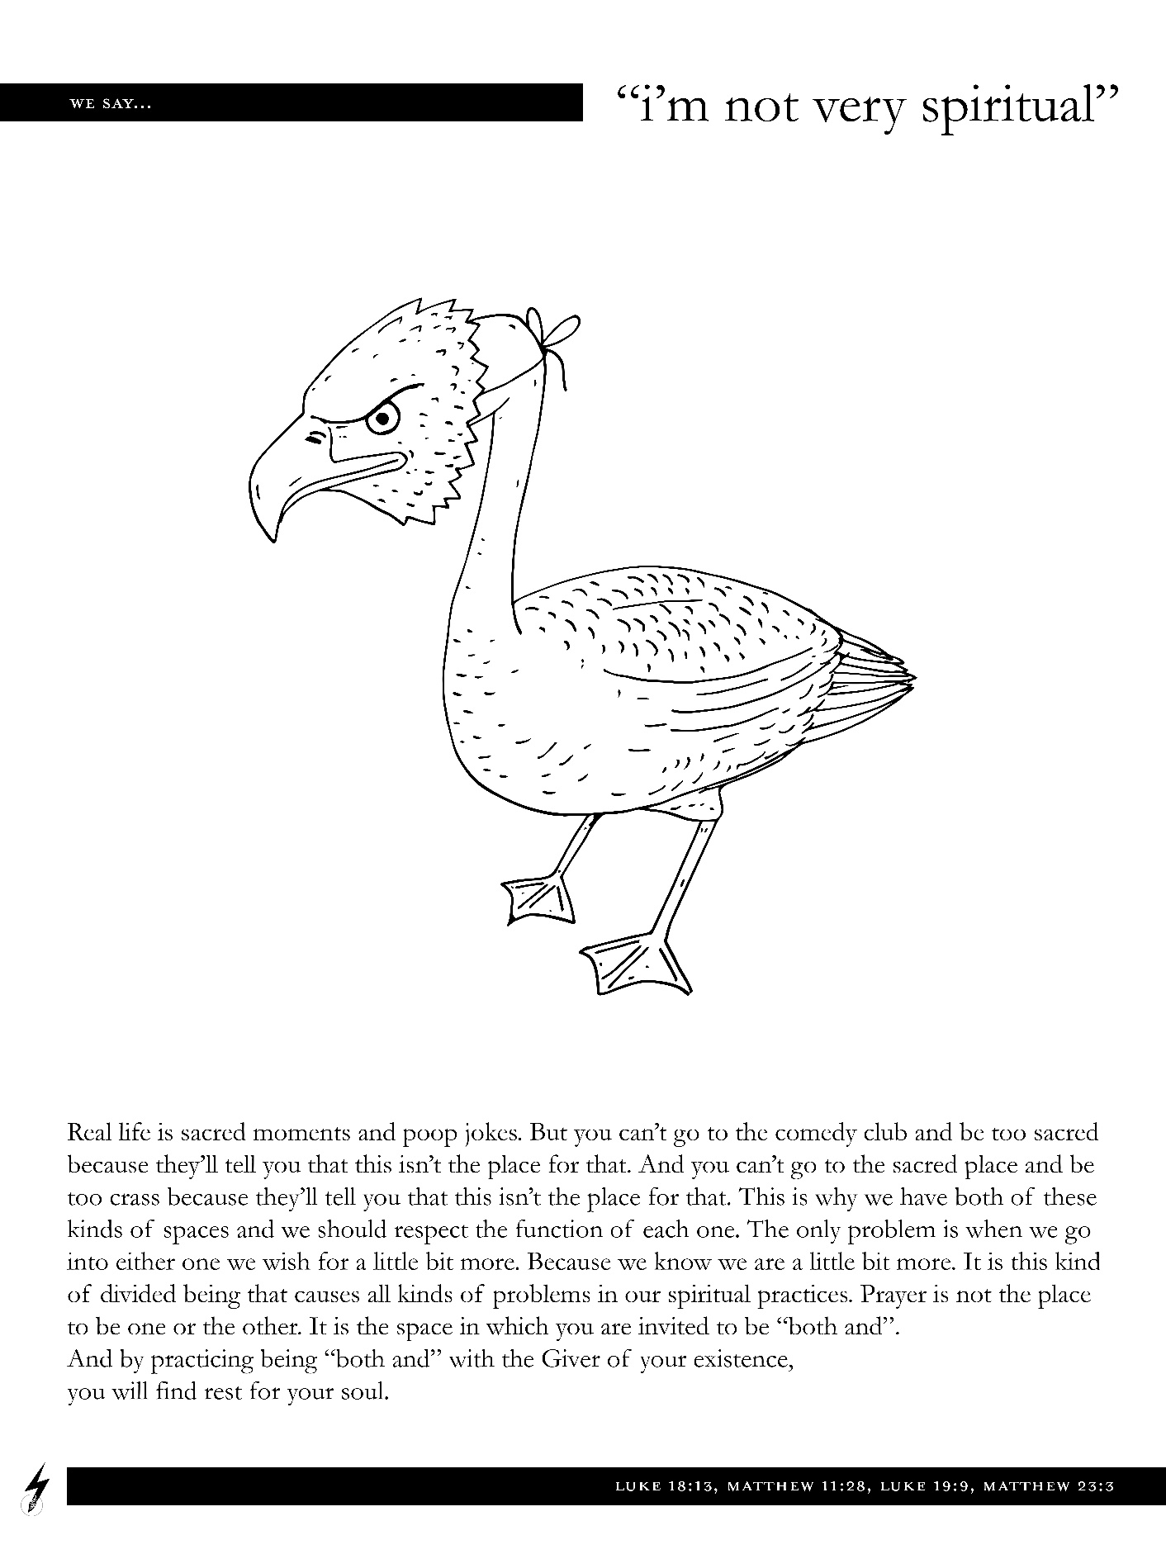
When his friends asked Jesus, “Lord, teach us to pray,” he gave them some general instructions followed by what is known as the Lord’s prayer. In previous weeks we have explored what it means to pray, as Jesus taught us, “Our Father in heaven, may your name be kept holy.” Today we will briefly explore what we mean when we pray,
“May your Kingdom come soon.”
I am struck by how easy it is to do with this prayer that Jesus taught us exactly what Jesus told us not to do in his instructions about prayer. Talking about prayer generally, Jesus said, “don’t babble on” (Mat. 6:7).

In other words, we miss the point if this prayer that Jesus taught us becomes merely words that we repeat on a regular basis. The Lord’s prayer is more about how you walk through life than about the right words or thoughts. Put another way, with this short prayer Jesus captured a way of life.
When we pray, “may your Kingdom come soon,” we adopt a particular vision for what life is all about. When praying, “may your Kingdom come soon,” we commit to working towards a certain goal.

Jesus uses the phrase “kingdom of God” or “kingdom of heaven” a lot. It is a convoluted and nuanced concept which is why Jesus used parables and images to talk about it. Generically speaking, the kingdom of God is about things being the way they are supposed to be. In the form of poetry Isaiah describes it this way:

In that day the wolf and the lamb will live together;
the leopard will lie down with the baby goat.
The calf and the yearling will be safe with the lion,
and a little child will lead them all.
The cow will graze near the bear.
The cub and the calf will lie down together.
The lion will eat hay like a cow.
The baby will play safely near the hole of a cobra.
Yes, a little child will put its hand in a nest of deadly snakes without harm.
(Isaiah 11:6-8)

Praying “may your Kingdom come soon,” is about accepting the invitation to live a life aimed towards this day when everything will be the way it is supposed to be. On that day, “there will be no more death or sorrow or crying or pain. All these things are gone forever” (Rev. 21:4).
Until that day we are invited to pray “may your Kingdom come soon” and by praying it we commit to living lives aimed towards making visible God’s desire for all humans to flourish.

As Albert Haase puts it, the kingdom of God comes to realization around us when we “engage the world and bring peace, love and justice to it” (Haase, Living the Lord’s Prayer, 93).
- How can you partner with God and work towards the flourishing of all people?

Perhaps one way to explore what this might mean for you is to ask yourself, "What am I passionate about?"

As always, I would love to hear from you.

Andreas

