Hi everyone,

Today is Father's Day. To be honest, I don't really know what Father's Day is supposed to be about. Growing up in Germany, Father's Day meant that otherwise responsible Dads went on a "Bier Wanderung." The best translation I can come up with is "Beer Hike." Essentially it meant that you start hiking early in the morning with a group of other men. The first, last, and most important thing you do all day is drink beer.

I am not sure why but this year is the first time I am seriously thinking about what Father's Day is all about. My Dad could not have cared less about things like Father's Day. The reasons are complicated but certainly affect me to this day and probably for the rest of my life. Calling God Father, or even Daddy the way Jesus did (Daddy is the best translation of the Aramaic term "Abba" used by Jesus to intimately address God as Father), never made sense to me. I want to be a different kind of Dad to my boys than my Dad was to me. But what does it mean to be a good Father?

Intuitively I have known for a long time that when we call God Father, or Daddy, it cannot mean that God desires the kind of relationship with us that I had with my Dad! But what do we mean when we call God Abba, Father?

Henri Nouwen puts it so well: "Calling God 'Abba, Father' is different from giving God a familiar name. Calling God 'Abba' is entering into the same intimate, fearless, trusting, and empowering relationship with God that Jesus had. This relationship is called Spirit, and this Spirit is given to us by Jesus and enables us to cry out with him, 'Abba, Father.' Calling God 'Abba, Father' is a cry of the heart, a prayer welling up from our innermost being. It has nothing to do with labeling God but everything to do with claiming God as the source of who we are" (Spiritual Direction: Wisdom for the Long Walk of Faith).

In a way, when I call God Father, I am describing what I missed in my Dad and what I am aspiring to be to my boys. There is a story in the Gospel of Luke depicting God as a Father of two sons. One son rejects his Dad and runs away to pursue what he thought is freedom only to find out that we cannot be truly free as long as we run away. Eventually he journeys back to his Father and is surprised to find his Daddy: someone who’s love is not dependent on how, or what, you do; someone who loves you the way you are and yearns to be close with you. We call God Father because of this unconditional, nurturing, free, and embracing love. Nothing we could possible do, say, or think can add or take away from how we are loved by God.

Henri Nouwen spent a lot of time meditating on Rembrandt’s famous painting “The Prodigal Son.”

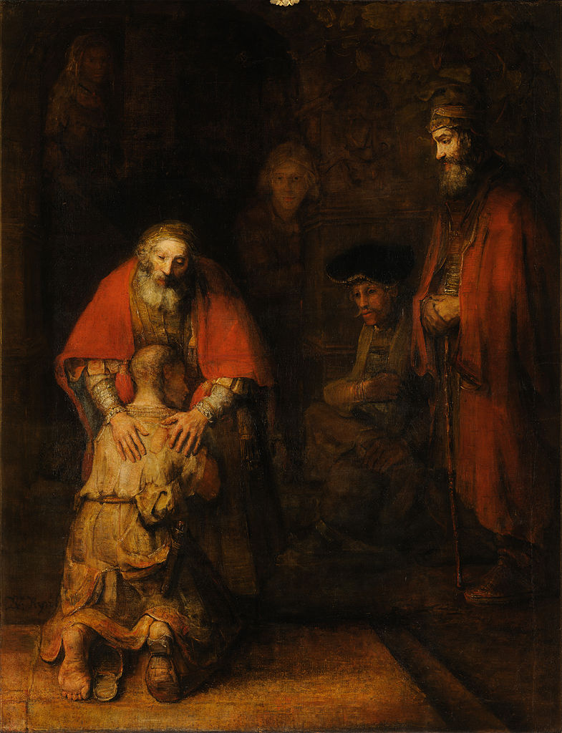

He points out that “a closer look at Rembrandt’s painting also reveals the image of a loving mother receiving her son home. God is personal yet beyond gender limitations. What I see in Rembrandt’s painting is that the welcoming figure is not only a father who ‘clasps his son in his arms’ but also a mother who caresses her child, surrounds him with the warmth of her body, and holds him against the womb from which he sprang.”
Henri Nouwen concludes that “the parable of the prodigal son is a story that speaks about a love that existed before any rejection was possible and that will still be there after all rejections have taken place. It is the first and everlasting love of a God who is Father as well as Mother.”

So Happy Father’s Day, I guess. More importantly, may we all experience this loving embrace by our God and become mirrors of this love to others. Father’s Day, in the end, is about specifically appreciating how Fathers have the potential to mirror the love of God to their children.

